From novice to competitor in marksmanship
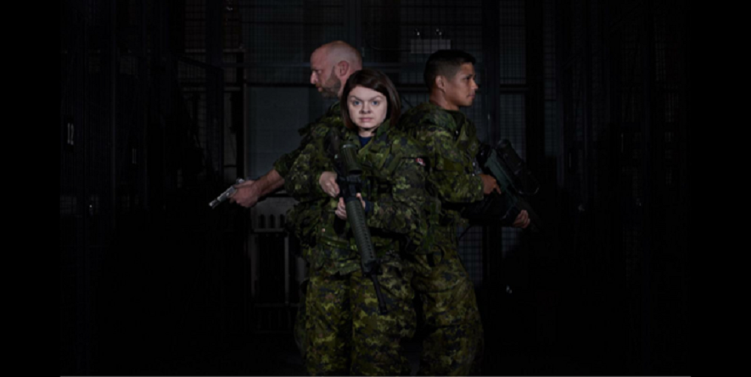
Early in 2018, Lieutenant Carole Bernier got introduced to marksmanship. Only a few months later, she was competing alongside some of the best shooters in the world! In September, she participated at the 2018 Canadian Armed Forces Small Arms Concentration (CAFSAC) at the Connaught ranges. What began as a desire learn to handle arms more comfortably has blossomed into a new passion.
Lieutenant Bernier is at the very beginning of her military career. She finished her Basic Military Officer Qualification (BMOQ) in December 2017, and now works as a nurse with the Canadian Forces Health Services (CFHS). She states, “I always wanted challenge myself, set goals and work to my maximum ability.”
She was first introduced to marksmanship by a colleague at the JAG who intended to join the NDHQ Marksmanship Team. “I did not consider myself very skilled with weapons, not coming from a family of hunters, my only experience with weapons were from my BMOQ course.” During her BMOQ she had been intrigued by small arms so afterwards she contacted Major Jason Das, the captain of the shooting team. Major Das made her feel welcome to join the Marksmanship Team, and she did!
In the beginning, Lieutenant Bernier’s objectives were modest, “I wanted to familiarize myself more thoroughly with the CAF’s service weapons and handle them comfortably.” She confesses that at first her confidence did take a hit when practicing alongside experienced marksmen. From May to August she became a fixture at the range and her shooting skills improved. “At each practice, I learned something new.” Soon, she could calculate wind drift and make the appropriate adjustments to her weapon. “I can say proudly that I have shot a bullseye with a C7 at 500 meters!”
“It was challenging being the only woman, Francophone and the only true novice on the team,” she relates, “But I soon discovered that on the range no one cares about your sex, language or level of experience as everyone is there because they’re passionate about shooting. Although very competitive my teammates were more concerned about outdoing themselves and scoring better than the last time. I think it's this last aspect that attracted me to this sport.”
When her team members informed her she was going to participate in CAFSAC - the annual shooting match for CAF and foreign military teams using rifles, pistols and light machine guns - she accepted. She understood the magnitude of the competition on the event’s first day, as competitors from across Canada and NATO countries were participating. She was going to shoot alongside the best shooters in the world! As a novice she felt privileged to participate in such an important event. Lieutenant Bernier also participated in dynamic matches with the pistol and the C7. Few people in the CAF, especially in the medical branch, have had this chance and she considers herself fortunate.
With home-team advantage, the competition at the Connaught Ranges passed in a whirl of activity. She was pleasantly surprised by her performance, doing better than she anticipated. “I did not win a medal but much more importantly I discovered a new passion, friends and very precious memories.”
The CAFSAC experience has changed Lieutenant Bernier as a soldier and a person. She believes that all members of the CAF regardless of their rank, element or trade should have the opportunity to participate. She advises anyone considering on joining, “Do not stop and think: I'm not a good shooter, I'm too slow, too busy, I do not like weapons and I only use them if I do not have a choice, etc. The more you practice, the more skilled you become. We do not become a good marksmen to kill, we become proficient for times when facing danger have to defend our life and that of our comrades, because we are soldiers first and foremost.”

